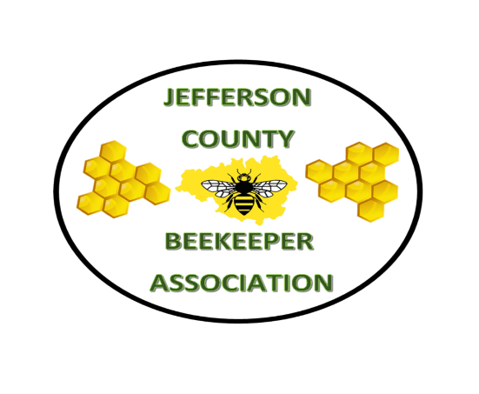
May 1, 2021 Vol 5
CLUB INFORMATION
President-Doug Rush
Vice President- Richard Ratigan
Secretary-April Johnson
Treasurer-Kip Davis

Meetings are the second Sunday of each month at 1 pm. We meet outside at the Apiary when weather permits. Next meeting is May 9, 2021, 1pm at the Apiary.
Dues include membership to Colorado State Beekeepers Association.
Website is www.jeffcobeekeepers.org On Facebook at Jefferson County Beekeeper Association Group

LAST MEETING NOTES
March 21, 2021
David Baker from Too Bee or not Too Bee was guest speaker on Diagnosing Dead Outs.
He talked about Varroa, absconding, dead bees with their head in the cells and butts up. Look for mites in the empty cells-mite poop is visible. AFB is rare but important to recognize. Wax moths do not kill a colony but will move into a weak colony.
The shop TOO BEE OR NOT TOO BEE will be opening soon in person and curbside. They will have queens around April 8th, call the store for more information.

April 11, 2021
We met at the apiary with 32 people attending. Dues were collected and new members welcomed. Doug opened the meeting with a request for membership dues and some general spring maintenance suggestions.
Seth Charbonneau spoke about the upcoming SBA queen rearing program that JCBA will be participating in. Eric Smith, president of CSBA, was present and added his perspective to Seth’s presentation.
Kathy showed the new Layens Horizontal Hive that was so graciously gifted to the club. Books “Keeping with a smile” about natural beekeeping and the Layens hive were distributed, also given to the club with the hive.
Sue Rieck talked about the “Hives for Heroes” program.
A swarm list was started. April will be the club’s dispatcher for swarm calls that come from CSBA Swarm hotline. 1-844-SPY-Bees (1-844-779-2337).

If there is a topic you want us to provide or want to share or write an article let us know. Write to jeffcohoneybee@gmail.com

COLORADO STATE BEEKEEPER ASSOCIATION

New things happening at the Colorado State Beekeeping Association. CSBA has started a new Sustainability Education Program for Affiliated Member Associations and clubs. Feedback indicated there is a great interest in this type of program. A simple Queen Rearing Program to improve local genetics and then share them was started on April 18, 2021. The training was for club members who will be trainers for their clubs. Two trainers from each interested club attended training on April 18, 2021. They will then teach the members in their clubs how to continue the Queen Rearing Program thus promoting local queens and bees. In July we will focus post honey flow splits and overwintering so that the following season we will have nucs to not only cover our own winter losses but have a surplus to share with others from the clubs.

The Colorado Master Beekeeping Program is now offering Apprentice Level classes. There will be 7 on-line classes discussing swarm management, familiarization with hive situations, pests, and diseases, feeding, pheromones and prep for winter. Apprentices will take a written exam and field exam. Contact the Master Beekeeper Program through the Colorado State Beekeeper Association. See www.coloradobeekeepers.org for more information.

MENTORING
There are many reasons why beekeepers are beekeepers. What are yours? If you want a mentor or willing to be a mentor let us know and we will set, you up.

APIARY

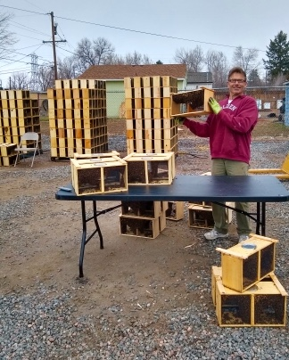

We want to give a big thank you to Dakota Bees, Greg Rye, who donated 2 packages to the club. They were installed on April 25, 2021. So now there are 3 hives with bees at the Apiary.

Thank you, Greg Rye.

WELCOME NEW MEMBERS

We want to welcome all mew members so far this year. Including Nikki B., Matt B., Fred B., Sarah D., Daniel and Ashley, Sarah J., Laura K., Janet L., Josh M., Peter M., Brigid M., Gretchen M., Gail M., Craig N., Lisa P., Jessica and Garrit P., Melody S., Joe, and Chris Y.

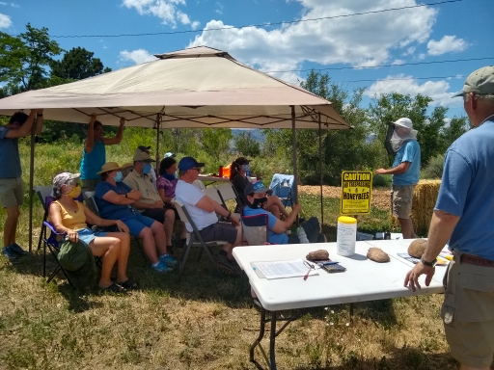

WHAT DO YOU KNOW?
1. ___Neither wasps or hornets depend on pollen for the rearing of their young, thus their bodies lack plumose hair and special structures for collecting and carrying pollen. (True or False).
2. Which insect often invades honey beehives stealing honey and even attacking brood?
3. Packages of honeybees are normally sold in two-, three-, four- or five-pound sizes. A pound of bees is approximately:
A. 10,000 bees C. 3,500 bees E. 2,500 bees
B. 15,000 bees D. 5,500 bees

Which state is the sunflower state??????

Answers on page 9.

CSBA QUEEN REARING PROGRAM

John Claus and Kathy Gill attended the initial trainer class on April 18, 2021. Several clubs were represented as well as, CSBA board members. We brought unfinished cell-builder units to the class and were shown how to complete them. Seth taught the group how to use the cell builder as well as the mating nucs. Everyone went home with a complete foam mini mating nuc. The plans for the cell builder, mini mating nucs, and other information are on Facebook. https://www.facebook.com/groups/csbaqueenrearing Anyone interested in learning the queen rearing program and being part of the state program please contact Kathy Gill Kathyg5458@live.com or John Claus at johnclaus@fastmail.fm

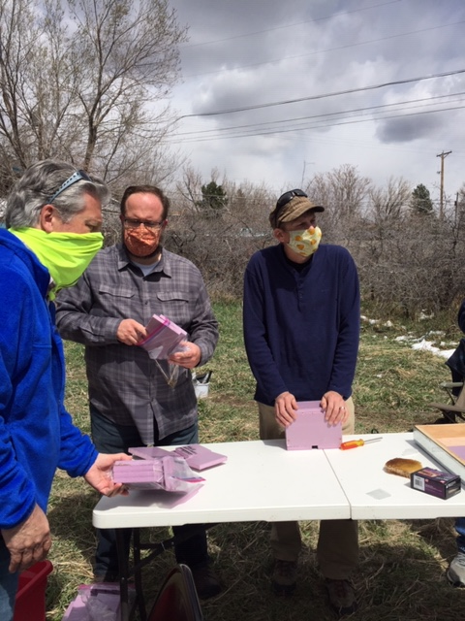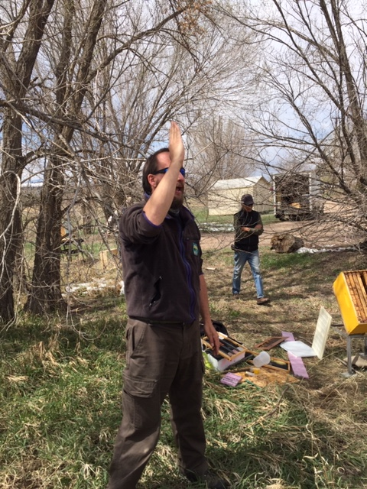

JUST SOME THOUGHTS
Here it is April 2021 and another snowstorm. Considering April is Colorado’s second highest month of moisture, it is not uncommon. The Colorado Climate Center has information on climate, maps, graphs, normal and extremes. https://climate.colostate.edu
Because of crazy Colorado weather, beekeeping in Colorado, may be challenging. We do early hive inspections in March. April comes the weather warms up and early blossoms appear dandelions come up. The queen is laying, worker and drone brood are appearing and emerge. We think ahhh…, spring at last.
Then we get hit with a storm and it drops 4-5 inches of cold, heavy, wet snow. The cold snap may last a day, a few days, or a week. Did we prepare? What do we do or should have done?
It is a good idea for beekeepers to keep an eye on the weather through the Farmer’s Almanac, digital apps, or the weather channel. Knowing what potentially the weather may be helps us prepare for the inevitable.
Beekeeper tasks include those early spring hive inspections to know what is happening in the hive. We check for the queen, eggs or larva, worker brood and drone brood. We look what food stores are available or not available to the hive and act accordingly. Is there honey or sugar blocks in the hive? Is pollen coming in? We add pollen substitute for the nurse bees to raise the brood if no pollen. If mine need honey frames, I add some that I keep from other hives or remove that are disease free. I put frames of honey in my freezer, but that is just me. Honey frames can be stored in a bin outside.
Knowing when a storm is due and anticipate temperature drops and snowfall, and preparing our hives with whatever they need, gives our bees the best start to spring.
Once the snow and cold hit, as soon as possible, check the hives to make sure the entrance is not blocked by snow. Check that water or snow is dripping away from the entrance of the hive. Make sure no tree limbs, or debris have fallen on your hives. Then go in the house have some coffee, tea or hot chocolate and relax your bees are just, fine.

POLLINATOR PARTNERSHIP 2021 MITE-A-THON
Mite-A-Thon is a tri-national effort to collect mite infestation data and to visualize Varroa infestations in honeybee colonies across North America within a two-week window.
Spring dates are May1st-16th, 2021. Summer: August14th-29th
There is no cost. Go to Miteathon@pollinator.org or call 415-362-1137 for more information and to sign up.
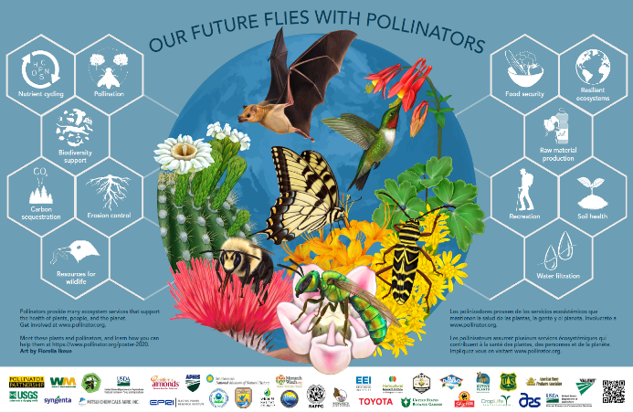
POLLINATOR WEEK IS JUNE 21-27, 2021.
Pollinator partnership gives us these facts; more than 1,000 of all pollinators are vertebrates such as birds, bats, and small mammals. Most (more than 200,000 species) are beneficial insects such as flies, beetles, wasps, ants, butterflies, moths, and bees. In the U.S. pollination produces nearly $20 billion worth of products annually. Monarch butterflies have declined by 90% in the last 20 years. 25% of bumble bees species are thought to be in serious decline.
Pollinator Partnership’s mission is to promote the health of pollinators, critical to food and ecosystems, through conservation, education, and research. The organization works all over North America and globally, managing various programs that promote pollinator health and provide public and private partners with the tools to get involved. Check out their web site for more information guides and programs. www.pollinator.org

HIVES FOR HEROES
Hives for Heroes Save Bees Save Vets is a national military veteran non-profit organization that supports and empowers veterans through beekeeping. As veterans are familiar with uniform, dependence on one another and going into vulnerable situations, thus beekeeping is a perfect fit for a healthy transition from service, suicide prevention, and honeybee conservation. The program started in 2020 in Texas with 6 members and has grown to more than 800 interested veterans in all states nationally in 2021.
The program pairs local beekeepers as mentors with veterans interested in beekeeping as a hobby (and therapy! We all know how therapeutic working with our girls can bee). There are applications for new bees and mentors that can be filled out on the following website: https://www.hivesforheroes.com. There was an initial orientation and meet-and-greet early in the season. Communication between the veterans and mentors is then established.
This will be followed by monthly support meetings nationally over Zoom for the veteran new bees and a separate monthly meeting for all mentors to help make the program as successful as possible. In the first year the veteran new bee shadows the mentor and assists with beekeeping tasks. The mentor can share learning resources, encourage new bees to join local bee clubs and educate as they see fit to help the new bee become a successful beekeeper in the future. Of course, sharing “Ask 3 beekeepers and you’ll get 5 answers” is a must. ;-) After the first year, the veteran decides whether to move forward with beekeeping on his/her own and will receive a nucleus of bees from their mentor at the time of splits the following spring. As the relationship is established, continued sharing is welcomed.
So, the organization is a national network of beekeepers and veterans providing connection, purpose, and healthy relationships fostering a lifelong hobby in beekeeping.
By Sue Rieck

THE LAYENS HIVE
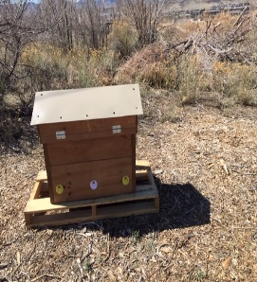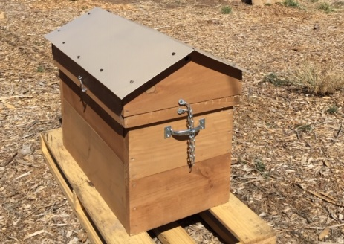
The Layens hive is a Horizontal hive holding 20 large frames 13 inches long by 16 inches deep. It is a single-box beehive designed so that honeybees build comb structures parallel to the ground. The deep frames allow the bees to create their comb similarly to what they would naturally, in a hollowed out, tree. Layens, the original developer of the Layens Hive, felt this construction gave the bees better access to their honey stores in the winter, giving them an increased chance of survival.
The hive has three entrances which can be closed or open according to which spaces have frames of bees. Division boards are used to isolate the number of frames being used from the frames that are not being used. Division boards also separate the frames when installing a swarm, or to force bees to build exclusively within the space the beekeeper gives them. The frames for the clubs’ hive are foundationless except for a one inch, strip of plastic foundation at the top for the bees to start their comb building. The deep frames have a dowel inserted in the middle to add strength to the comb. Sometimes other foundationless frames have wires stretched from top to bottom, every few inches, to give strength to the comb. Because the frames are foundationless, they must be carefully turned or manipulated when doing inspections or the comb will fall off. The bees will maintain the brood primarily near the entrance, and excess honey will be stored by the bees further away.
The advantages of any horizontal hive are multiple. They include no heavy lifting of full deep brood boxes or supers, all the frames are the same size, large combs for strong spring buildup, overwintering, and no extra storage space because the unused frames are stored in the hive box. Some Layens Hives are made of thicker walls for better insulation. There are minimally invasive hive inspections because you only remove one frame for inspection and the others remain covered by the top of the frames. Honey harvest is achieved by pulling full honey frames and then using a crush and strain technique. Alternately one can cut off the comb with a knife and use or sell the comb with honey in it. Because it is comb honey no extractor is necessary.
The things to watch out for are cross comb, connecting multiple frames. You want to catch it early to correct it or it really becomes a significant problem. The Layens hive concept is to let the bees live as they do in the wild with fewer inspections allowing them to be stronger and more resilient against pests. It still should be inspected for pests, and varroa. Inspections must include making sure the queen has enough space to lay and the bees have enough space to put honey. By Kathy Gill, Jessica and Gerrit Padgham

BEE FACTS
Can’t Find the Queen? If you see eggs. You know there was a queen 3.5 days ago.
If you see larva but no eggs, you know there was a queen between 4-9 days ago, depending how big the larva are.
If you see capped brood but no eggs or larva you know there was a queen 9 days ago. Bees cap the open brood on day 8-9.
What is a caste? Caste means Queen, Worker, or Drone.
What is the difference between hatch and emerge? Eggs hatch after about 3 days no matter what caste. Queens emerge or come out of the cell in 16 days. Worker bees emerge in 21 days. Drones emerge in 24 days.
BOOK REVIEW
Queen Spotting by Hilary Kearney
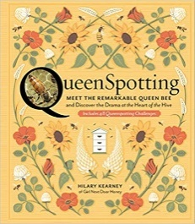
Copyright 2019. Storey Publishing. 127 pages.
Hilary Kearney is the creator of Girl Next Door Honey, a beekeeping business that educates new beekeepers each year. She has a blog, Beekeeping Like A Girl. She has written for other publications. Kearney rescues swarms and manages 90 hives in California.
The author describes why to find the queen, how to find the queen, swarm cells, and what happens inside the hive. She shows different pictures of a wide range of queen colors and talks about the life of a queen. She offers clear illustrations of a queen and her entourage. The challenges to find a queen on the pages of the book are categorized as easy, intermediate, and advanced. This book is easy to read, informative, and fun. By Kathy Gill

I saw this sign recently and wanted to share it.
This sign can be prominently placed around an apiary or yard. See the statute by going to page 243. https://leg.colorado.gov/sites/default/files/images/olls/crs2018-title-13.pdf

WARNING
UNDER COLORADO LAW, THERE IS NO LIABILITY FOR THE DEATH OF OR INJURY TO A PARTICIPANT IN AN AGRICULTURAL RECREATION OR AGRITOURISM ACTIVITY RESULTING FROM THE INHERENT RISKS OF THE AGRICULTURAL RECREATION OR AGRITOURISM ACTIVITY, PURSANT TO SECTION 13-21-121,
COLORADO REVISED STATUES.

1.True The bodies of hornets or wasps are relatively smooth and shiny. The bodies of bees are covered with plumose hairs that are used for the collection of pollen. Wasps and hornets do not depend on pollen for the rearing of their young thus lack the body structures needed.
2. Yellow jackets
3. 3,500 bees

3. 3,500 bees

RECIPES
Easy BBQ Sauce
1 medium onion, finely chopped (not a sweet onion)
1 tablespoon ground coriander
2 tablespoons honey
¼ teaspoon freshly ground, black pepper.
1/4 teaspoon garlic powder
1/8 teaspoon cayenne pepper
3 tablespoons lemon juice
¼ cup soy sauce
In a saucepan, combine all the ingredients over moderate heat and simmer for 5-10 minutes, until thickened as desired. Do not bring to a boil. Do, however, taste now and then and add additional spices (salt, cayenne pepper, garlic powder, or black pepper) to taste before removing from the heat.
To use barbeque sauce on the grill: Cook meat about halfway through on both sides (by turning once before adding the sauce). Add the sauce evenly with a brush to one side. When the first side is finished cooking, turn the meat, add sauce to the second side, and finish cooking. Makes ½ cup.
______________________________________________________________________________
Sweet Summer Salad
1 cup cubed watermelon
1 cup cubed cantaloupe (preferably Rocky ford when available)
1 cup cubed honey dew
1 cup blueberries
juice of one lemon
½ cup honey
¾ cup whipped cream.

In a large bowl, mix the watermelon, cantaloupe, honeydew, and blueberries. Dribble the lemon juice all over the fruit then drizzle with the honey. When mixed, refrigerate for at least an hour. Just before serving, fold in the whipped cream. Serve in a clear glass bowl.
Variations on the whipped cream
Chill the cream before whipping. Add ½ teaspoon vanilla and 1 tablespoon of the same honey used in the salad. Whip until you get soft peaks, and then keep chilled until needed. Makes 8 servings.

